Protective Clothing & Workwear
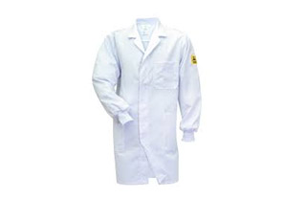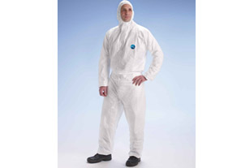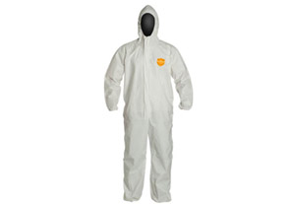

ESD Clothing DUPONT TYVEK SUIT DUPONT PROSHIELD

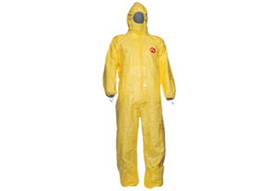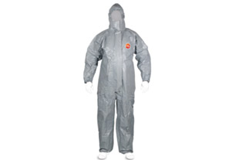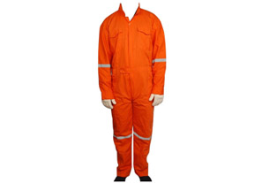

DUPONT TYCHEM C TYCHEM F BOILER SUIT

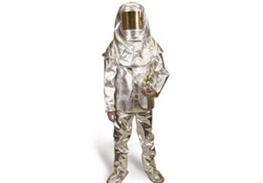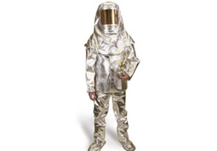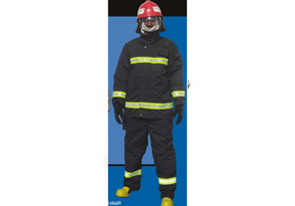

ALUMINIZED 3 layer suit FIRE PROXIMITY SUIT NOMEX FIRE SUIT

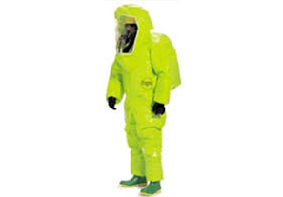

SCBA ENCAPSULATED SUITT

